Problem 3:-

B)deleting the eigen values which are to the top left, deleting the eigen vectors which are to the left help in reducing ,since the eigen values to the left are less compared to the eigen values to right, their influence on the final image is very less.

A)
Original Image
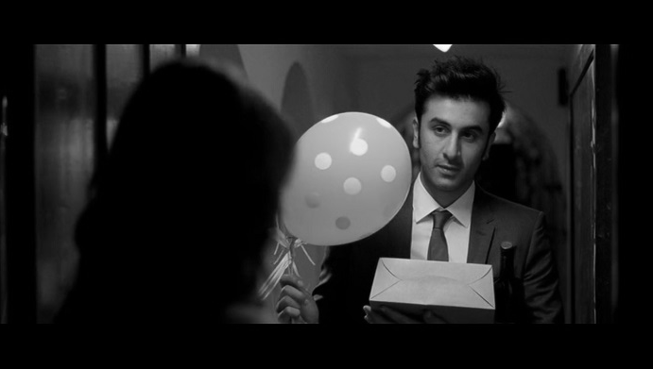

with only 15 columns out of 699

with 30 columns in 699


with 45 columns in 699
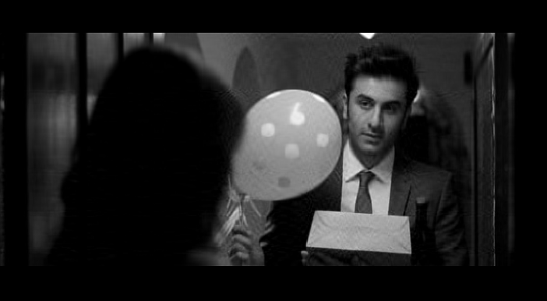
with 50 columns in 699
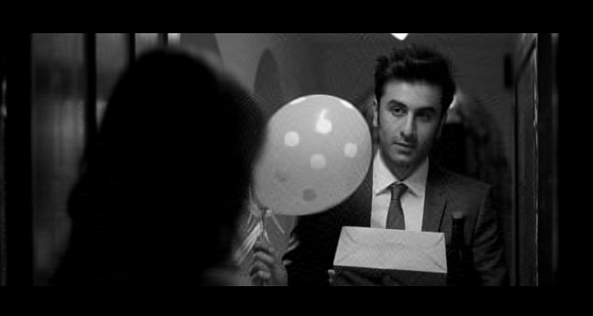
I find when only 50 columns are maintained in the eigen vectors the quality is almost retained.
There fore,
c) ratio of compression=(699-50)/699

Analysis with an image with more whiteness
with 50 out of 782


with 100 out of 782


original image


c)therefore here the compression ratio is (782-100)/782

